PLEASE JOIN U S FOR A BREAKFAST RECEPTION IN CELEBRATION OF

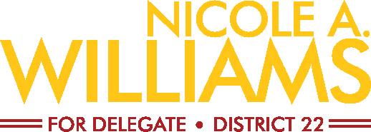
DECEMBER 16, 2019 • 9:00 A.M.–11:00 A.M.
United Food and Commerical Workers - Local 400
8400 Corporate Drive, Suite 200, Landover MD 20785
Sponsor: $1,000 • Host: $500 • Friend: $250 • Guest: $100
To RSVP, or with questions, please contact Robert L. Williams at 301.967.1049 or robert.williams.07@comcast.net
Contribute Online: https://secure.actblue.com/donate/ufcwlocal400#
Please make checks payable to Friends of Nicole A. Williams; Mail to: 7722 Hanover Parkway, T4, Greenbelt MD 20770
Individuals, corporations, associations, and partnerships may contribute up to $6,000 to a Maryland non-federal campaign account during each four-year election cycle (Jan. 1, 2015 to Dec. 31, 2018). Contributions or gifts to Friends of Nicole A. Williams are not tax deductible.
BY AUTHORITY: FRIENDS OF NICOLE A. WILLIAMS, ROBERT L. WILLIAMS, TREASURER.
FRIENDS OF NICOLE A. WILLIAMS
BY AUTHORITY FRIENDS OF NICOLE A. WILLIAMS, ROBERT l. WILLIAMS, TREASURER.
7722 Hanover Parkway, T4, Greenbelt MD 20770 * (301) 458-0340
YES, I will attend the reception on December 16th. Please reserve:
Sponsor(s) at $1,000; Host(s) at $500; Friend(s): $250; Guest(s): $100
NO, I cannot attend, but I’d like to support Nicole Williams. Enclosed is my contribution of $ .
NAME ORGANIZATION
ADDRESS CITY STATE ZIP
MOBILE PHONE WORK PHONE EMAIL
In order to comply with State law, contributors are required to provide their employment information.
EMPLOYER OCCUPATION
Please make checks payable to: Friends of Nicole A. Williams, or contribute by credit card below.
I would like to make my contribution using my: VISA MasterCard Discover AMEX
NAME AS IT APPEARS ON CARD
CARAD NUMBER EXP DATE SECURITY CODE
BILLING ADDRESS CITY STATE ZIP CODE

